Few appreciate the immense value to a business, that your delivery Team can add.
Delivery staff visit your Customers more often that your Sales Reps ever do.

Even during lockdown, they still got to call, when Reps were being chased away.

Therefore, providing skills education on Customer etiquette & careful road manners; putting on a friendly & professional face & dress, will jump start your Customer satisfaction ratings immeasurably.

Further, your it is your Driver who alone, has access to so much business intelligence! They talk to the Customer staff & get to see the storerooms.

Draw them into your sales process, & you will be amazed at the business intelligence ~ often crucial information ~ they can supply you about each Customer.

Small rewards & recognition can turn an ordinary Driver into a powerful resource.

And soon, you will find your next best Sales Professionals will be coming internally ~ yes, exactly ~ from your own delivery Team ~ goodbye hefty placement fees & goodbye to lengthy training on your systems for newbies!

This course highlights to both Driver & Management, the key & unique position they hold on your team, as well as outlining untapped sales growth opportunities!

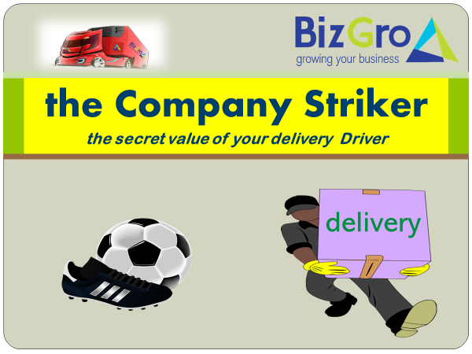

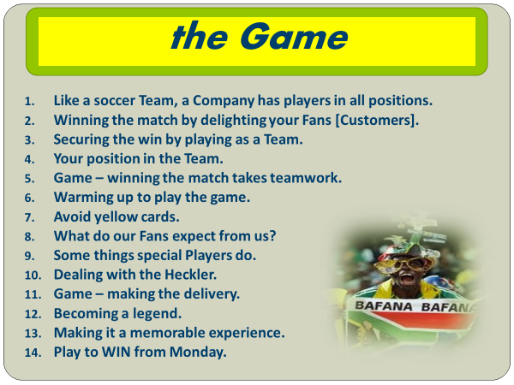

Gamified in football terms, making learning easy & meaningful
Strict social distancing protocol practiced

You stand to benefit ~
- A competent & motivated delivery team
- Improved Customer satisfaction
- Valuable business intelligence
- Insight into your next sales superstar/s ~ from within
Details ~
booking per training session: 1–10 delegates R3,900 + VAT /// 11–20 Delegates R4,900 + VAT
* maximum 20 pax
* duration ~ half day
* excludes venue & refreshments
* includes handy post-course guide
* includes competency test outcome
* includes sales aptitude for future career growth
* certificate of accomplishment
Book your Team now & WIN SALES ……………..

