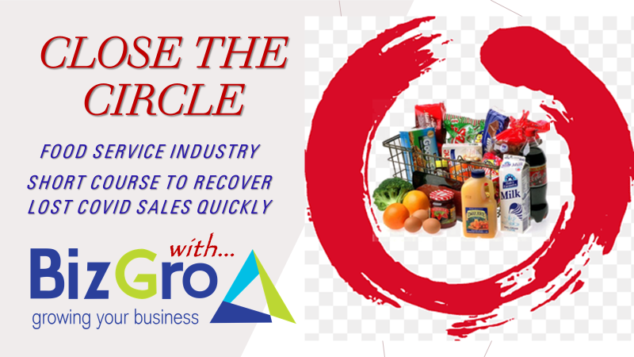
BizGro’s latest sales training intervention helps Food Service Distributors increase your basket sales to Customers.

Adding a line to every order generates bottom-line profit without increasing your expense line.

Simply measure your top 100 lines sold & work out how many Customers participate in purchasing all of them. Next could they be buying them elsewhere? For sure!

And if they are ~
for sure your pricing will remain under pressure as the seek MORE, & they will continually scoop more of your existing lines sold to that Customer.

So why are Customers NOT buying the low hanging fruit?

Would you say its price related?
Your Salespeople will claim it to be so!

In truth, the most common challenge is simply a case of Sellers focussing on your fastest & easiest to move lines, to earn their sales & commission!

This low hanging & most profitable fruit is most often forgotten…….
This in depth & mind changing workshop, provides a refreshing energy & new look at sales.

Test your Team with ~
- Measure of your top 100 lines?
- Which of your existing Customer base currently buys all of them?
- If not, what is the reason. EG ~ do not use the product, or buy elsewhere?

At the same time, your Procurement Team should Manager approaches Suppliers of these bestselling lines & appeal for additional discounts & promotions.

Blow the bugles & rattle the drums!

And you WILL grow your turnover by 30+%, simply by applying the learning outlined in this half day course.

You have never invested in anything more valuable than “Close the Circle”.
This course guarantees you more sales from your existing basket………….

It costs the company no more to add lines to every delivery!

Book now & start earning more…….

Richard Lyon
083 625 7721
richard@bizgro.co.za

* face to face or Zoom training course
* R5,900 + VAT ~ up to 8 field & 8 Internal Sellers per session

